**A TECHNICAL REPORT ON STUDENTS INDUSTRIAL WORK EXPEREINCE SCHEME (SIWES)**

**UNDERTAKEN**

**AT AFABROS COMPUTER COLLEGE,**

**MUBI, ADAMAWA STATE**

**FROM: 4TH JANUARY 2023**

**TO 4TH MAY, 2023**

**BY**

**HOSEA YAHAYA TSAMBIDO**

**ST/CS/ND/21/144**

**SUBMITTED TO THE DEPARTMENT OF COMPUTER SCIENCE, SCHOOL OF SCIENCE AND TECHNOLOGY, FEDERAL POLYTECHNIC MUBI,**

**IN PARTIAL FULFULLMENT OF THE REQUIREMENT FOR THE AWARD OF NATIONAL DIPLOMA (ND) IN COMPUTER SCIENCE**

**JUNE, 2023**

**CERTIFICATION**

This is to certify that this report compiled by HOSEA VICTOR YAHAYA with the registration number **ST/CS/ND/21/144** meets the regulation governing the award of the national Diploma in computer science, the federal polytechnic Mubi, Adamawa state and approved by

………………………………………. ………………………………..

HOSEA YAHAYA TSAMBIDO DATE

………………………………………… …………………………………

MR. MUSA SIMON DATE

(DEPARTMENTAL SIWES COORDINATOR)

…………………………………………. ……………………………….

MR. ADAMU GARABA DATE

(HEAD OF DEPARTMENT)

**DEDICATION**

I dedicate the technical report to God Almighty for His ultimate protection and divide guidance protection throughout the four (4) months of this industrial training program.

**ACKNOWEDGEMENTS**

My gratitude goes to God for His wonderful love and protection upon my life during the SIWES program and to my beloved family and friends for their prayer and support.

It will not be complete if I do not appreciate the head of the department of computer science (Mr. Simon Galadima), my supervisor and all my lecturers in the department of computer science

I also want to acknowledge the industry base supervisor (Engr. Mathias Afariyu) where I did my SIWES program and I also want to thank him for fatherly advice and words of encouragement, time, teaching and supervising my logbook.

I thank my colleagues whom in one way or the order have contributed to the success of the SIWES program.

**ABSTRACT**

*This contain information of the various activities that has been carried out during the four month mandatory student industrial work experience scheme (SIWES) in Afabros computer collage. The report consist of the four (4) chapters the first contains information about SIWES, importance and objective of SIWES. Chapter two contain description of the organization where I was attached, location /history and objectives. Chapter three contains of activities acquired during the IT and the last chapter which is chapter four consist of summary, recommendation, conclusion and reference.*

**TABLE OF CONTENTS**

TITLE PAGE - - - - - - - - - - i

DEDICATION- - - - - - - - - - ii

ACKNOWLEDGEMENT- - - - - - - - - iii

ABSTRACT - - - - - - - - - - - IV

TABLE OF CONTENT- - - - - - - - - v

CHAPTEER ONE

1.0 INTRODUCTION- - - - - - - - - 1

1.1 AIM OF SIWES - - - - - - - - - - 1

1.2 OBJECTIVES- - - - - - - - - - 1

CHAPTER TWO

2.0 DESCRIPTION OF AFABROS COMPUTER COLLEGE - - - 2

2.1 LOCATION AND BRIEF HISTORY OF AFABROS COMPUTER COLLEGE 2

2.2 OBJECTIVE OF AFABROS COMPUTER TRAINING - - - 3

CHAPTER THREE

3.0 ACTIVITIES I UNDERTOOK DURING MY TRAINING AT AFABROS COMPUTER COLLEGE, MUBI - - - - - - - - - 5

CHAPTER FOUR

3.1 SUMMARY- - - - - - - - - - 14

3.2 CONCULSION- - - - - - - - - - 14

3.3 RECOMMENDATION - - - - - - - - 15

3.4 REFERENCE- - - - - - - - - - 16

**CHAPTER ONE**

**INTRODUCTION**

The acronym (SIWES) which stand for “student Work experience scheme” is a practical training program designed to offer student the great opportunity to use the best equipment with the practical aspect of their development knowledge. The training which last for four (4) month was a necessity to all student in institution of higher learning, most importantly to those in polytechnic, universities of technology as it from part of higher national diploma, bachelor Degrees in science and technology. It help student to be familiar with handling equipment, crucial to work methods at the end of the training so that upon graduation he/she is practically fit for jobs relevant to his/her discipline

**AIM OF SIWES**

To provide student with the opportunities to apply their educational knowledge in real work situations, there by bridging the gap between theory and practice. It also enlist and strengthen employer’s involvement in the entire educational process through SIWES.

**OBJECTIVE OF SIWES**

1. To developed student practical knowledge in the perspective of their field of studies
2. To create job opportunity for student after their graduation
3. To create an avenue for student to share their idea and skill with other people in the society.
4. It is a mean of destiny, career, goal, and provision of working experience prior graduation.
5. It create gap between skill and unskilled people in the society
6. To prepare and expose student situation outside the academic environment

**CHAPTER TWO**

**DESCRIPTION OF AFABROS COMPUTER COLLEGE MUBI**

Afabros Computer College Mubi is registered computer company incorporated under the companies and allied Matter Act 1990 with an RCR No. 012949 and CERT No. YLZ000304 and SERIAL NUMBER 1238084, and is wholly indigenous company. The company is multidisciplinary with specialization /bias in computer training (Engineering, repairs, software development, web design, networking), sales of computer, and secretarial service

**VISION**

To led in the provision of information technology and communication technology (ICT) service and specialization in the industrial and entrepreneurial graduate for development of the society.

**MISSION**

To build more proactive ICT company and offer an improved level of service to all clients.

To provide the best cost-effective service and solution

**LOCATION AND BRIEF HISTORY OF AFABROS COMPUTER COLLEGE**

Afabros Computer College is a private computer college, located in Mubi north local government of Adamawa state Nigeria. It was established in 2003 as computer center and was called “Afabros computers”, where people came to type, print and a few students for computer training.

The company laid emphasis on job quality, truthfulness, accountability, dynamism and satisfaction at all, time. As people that have vision, the staff spent most of their time in their office trying to finish all task to satisfy the needs of the students .beside the students and their sponsor are always satisfied with the outcome of the training. These gave the Afabros a good name which is the above every other name in computing, and now tagged,

“AFABROS was tried was tested, and now trusted”

The company which started with one personal computer, now has well over 50 working computer and three (3) department namely: computer/Electronics Engineering Department, computer science Department and a secretarial Department. Afabros Computer College has now graduated over 5000 students as of 2021. Students from college of Education, federal and state polytechnics, federal and state Universities all come to Afabros Computer College yearly for their student industrial working Experience Scheme (SIWES) programs. People from neighboring countries such as Republic of Chad and Cameroon are many in Afabros Computer College.

Afabros Computer College actively encourages entrepreneurship by his students. Most business-oriented graduates are now self-employed such as Start Best Computer Uba, Borno State, Celesmac Computer Federal Polytechnic Mubi signabobo company Ltd. (Njamena, Chad Republic), among others.

**OBJECTIVE OF AFABROS COMPUTER COLLEGE TRAINING**

Afabros Computer College has been producing majority middle-level manpower that has been making valuable contribution to the social and economic development of Africa and the world at large. The objective of the college are:

1. To revolutionize the Afabros computer’s operation in line with dynamic of the operation environment
2. To commit to operational excellence and long-term thinking thereby education students on computer usage
3. To strengthen the Afabros brand, leverage and upscale the customers’ and students’ experience usage
4. To project Afabros computer college as sophisticated and dynamic

HEAD

COMPUTER SCIENCE DEPEARTMENT

HEAD

SECRETARIAL DEPARTMENT

**LABORATORY ATTENDENT**

**PRODUCTION MANAGER**

HEAD

ENGINEERING DEPARTMENT

**COMPUTOR OPERATOR**

CLEANER

SECURITY

SE

POWER MANAGER

ACADEMICE SECRETARY

DIRECTOR OF STUDENT

ORGANIZATIONAL CHART AFABROS COMPUTER COLLEGE MUBI

SIWES COORDINATOR

**CHAPTER THREE**

**ACTIVITIES I UNDERTOOK DURING MY TRIANING AT AFABROS COMPUTER COLLEGE, MUBI**

During the SIWES program I was opportune to have been introduced to the following programs: Microsoft word, power point, and web design using HTML

**3.1 INTRODUCTION TO MICROSOFT WORD**

Microsoft word is the typing, editing, storing, and printing of texts through an electrochemical device called computer. It can also be define as the act of manipulation characters to create a professional looking document through the computer.

**Some important keywords in the definition**

1. **Typing:** This is done by using the keyboard. The keyboard is it is known as input device. It has about 108 keys on it. There are five part of the keyboard namely: function keys e.g. f1-f12, computer keys e.g. Esc, ctrl, shift, e.t.c. Typing keys A-Z, Dedicating keys e.g. page up, page down, Arrow keys and Numeric keypad.
2. **Editing:** This is type act of correcting error (s) in a document. It is also involves rearranging the document so as to give a perfect, desire, and professional.
3. **Storing:** this is the same thing as saving a document into the permanent memory so as to able to re-call it any other time. It is needed. This should always be done frequently so as to guide against frequently power failure which can shutdown the computer and erase any file that has not been saved.
4. **Printing:** This is the act of getting the hard copy or the soft copy of the document through a device called a printer using paper.

**Loading (Starting Microsoft Word)**

1. Put on the computer and allow it to boot up and display the windows environment or desktop.
2. After booting, click on the start button.
3. Move the mouse to all programs
4. Click on Microsoft Office
5. Select Microsoft Word
6. Wait for the loading.

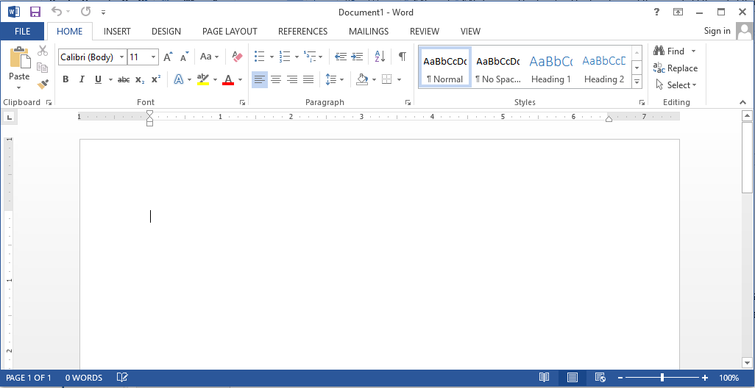

Figure 3.1: Microsoft word interface

**How to View Ms Word Using Keyboard**

1. Press start button from the keyboard
2. Press ‘ P ’ key
3. Press down arrow key to highlight Ms-Word.
4. Press enter key.
5. **Screen Element of Microsoft Word**
6. **Title Bar:** A place where application name of the user appears.
7. **Ribbon:** A place where all news name that is use to perform different task appear e.g. Office button, Home, Page layout, View, Format, e.t.c.
8. **Formatting Bar:** A place where icon that is used to change the attribute of our text e.g. B for bold, I for italic, U for underline e.t.c.
9. **Standard Tool Bar:** this bar show operation symbols that represent a command like new, open, save, print, print preview, copy, cut and so on.
10. **Scroll Bar:** it is denoted by the triangle icon and it is used to move page up and down, left and right.

**I LEARNT KEYBOARD SHORTCUT IN MIRCOSOFT WORD**

The keyboard shortcut keys are:

Control +A =select all

Control+ B = turn bold on or off

Control + C = copy selected object

Control + D = duplicate selected object

Control + E = center alignment of a selected paragraph

Control + F = find missing or hidden text

Control + G = go to specific page

Control + H = find and replace missing text or hidden text

Control + I = italicize selected text

Control + J = justify selected paragraph

Control + K =insert hyperlink

Control + L = left align of a selected paragraph

Control + M = left indent

Control + N = new blank document

Control + O =

Control + P = print dialog box

Control + Q = format paragraph

Control + R = right align of selected paragraph

Control + S = save dialog box

Control + T = hang intent

Control + U = under line selected paragraph

Control + V = past object after begin copied or cut

Control + W = close a file especially in Microsoft word

Control + X = cut selected text or object

Control + Y = redo last action

Control+ Y = undo last action

**3.2 NOTEPAD**

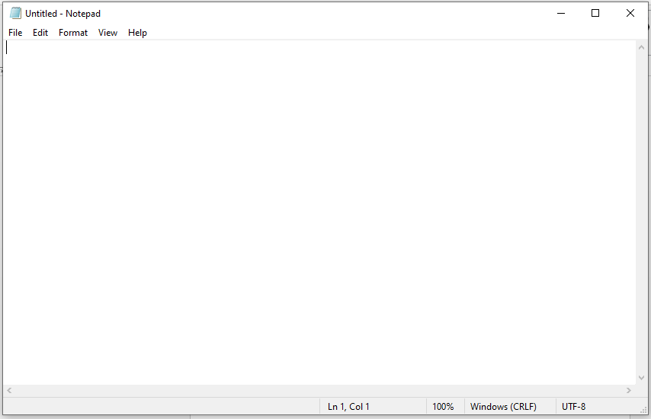

Figure 3.2: Notepad interface

**3.2.0 I LEARNT HOW TO LUNCH A NOTEPAD AND HOW TO CREAT A SIMPLE TABLE**

Start

All programs

Accessories

Notepad

**Then Type the following:**

<html>

<table border=1>

<td>serial number</td>

<td>name</td>

<td>registration number</td>

<td>course of study</td>

<tr>

<td>1</td>

<td> Hosea victor </td>

<td>ST/CS/ND/21/140</td>

<td>computer science </td>

<tr>

<td>2</td>

<td>Alhamdu Musa</td>

<td>ST/CS/ND/21/124</td>

<td>computer science </td>

<tr>

<td>3</td>

<td>Emmanuel Levi</td>

<td>ST/CS/ND/21/143</td>

<td>computer science</td>

<tr>

<td>4</td>

<td>Isaac Moses</td>

<td>ST/CS/ND/21/002</td>

<td>computer science </td>

<tr>

<td>5</td>

<td>Emmanuel James</td>

<td>ST/CS/ND/21/140</td>

<td>computer science</td>

<tr>

<td>6</td>

<td>Buhari Musa</td>

<td>ST/CS/ND/21/002</td>

<td>computer science </td>

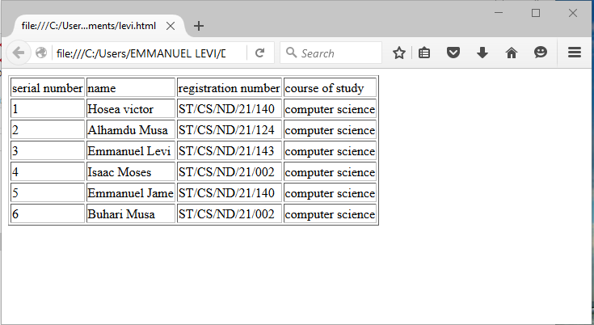

**3.2.1 I LEARNT THE MEANING OF SOME HTML TAGS**

<Opening tag

>closing tag

<br>break a line</br>

<b> to make bold</b>

<u> to underline</u>

**3.3 INTRODUCTTION TO MICROSOFT POWERPINT**

Microsoft PowerPoint is software which is included in the Microsoft Office suite that is very commonly used to create presentations for business settings. PowerPoint can make presentation easier to understand and more interesting, it can also be misused bad PowerPoint presentations can make people dread meetings.

**3.3.1 DEFINITION OF MICROSOFT POWERPOINT**

Microsoft PowerPoint is software designed to integrate grouping text into striking high impact presentations. Presentation are projected onto a screen for viewing by several people within a room by using an overhead projector connected to a computer PowerPoint. Stores its files format, with each file being comprised of what is known as presentation. Each presentation include notes which are not display on the projec5tion screen, but which can serve as prompts for the presenter.

**POWERPOINT IN BUSINESS**

PowerPoint has be become a staple in business presentation. The program is widely used both for live meetings and for creating graphically rich presentation which are distributed and in a file form by email or post in the internet. PowerPoint presentation are commonly used to present the results of research project, surveys and to provide a visual means of communicating the mission or strategic plans of a company

**VIEWING POWERPIONT FILEEA WITHOUT POERPOINT**

It is possible to view PowerPoint files without having PowerPoint installed on a computer. If the creator of the presentation has a PDF converter installed on her computer, the file can be converted to PDF format, which can easily be viewed in Adobe Reader which is a free download. Another option for computer user who do not have PowerPoint or Microsoft Office is to download Microsoft PowerPoint viewer free program which is available from the Microsoft website S, This program allow PowerPoint presentations to be viewed in their original format

**IMPORTANCE OF MICROSOFT POWERPOINT**

PowerPoint presentations are a way of attracting audience towards your views and arguments. It is one of the most helping factors behind success of every meeting. There are various user of PowerPoint presentations are in modern days learning, corporal training sessions, business and marketing meetings, and sales gatherings.

**LEARNING SOLUTIONS**

PowerPoint presentation combines audio and visual both aspects making it easier to understand for audience. Even the normal teaching or training becomes interactive by just using presentations in lectures. These days selecting colleges and institutions are providing tailor made presentations to students for different topics ion syllabus of study. That makes learning easier and interactive for Student.

**CORPORATE TRAINING SESSION**

Power Point is an essential ingredient of every corporate training session. Top executives and manger (marketing and sales) use less time consuming for corporate training. It’s always beneficial and in their sessions, it generates more results.

**MARKETING STRATEGY**

Powerful tolls and options present in Micro PowerPoint make it easier for people in marketing presentations for motivation of their subordinates. Inclusion of different types of charts, clip-arts graphical structures, makes a presentation eye catchy. Animation and sound effects add extra emphasis on these presentations making them interactive.

**GUIDELINES FOR AN EFFECTIVE SESSION:**

1. Your presentation should be point and focusing your over actual purpose.
2. There should be a professional look deciding your organizations identity.
3. You need to properly before delivering a presentation in any seminars.
4. There should be less text, user’s positive graphics in presentations.
5. Take care of your time, user positive responses, and their ease, don’t make people bored with longer duration, and presentations
6. There should be uniform colors and font appearance throughput the presentation to avoid in-convenience.

**CHAPTER FOUR**

**SUMMARY, CONCLUSION AND RECOMMENDATIONS**

**4.1 SUMMARY**

The whole experience gained during the attachment at AFABROS COMPUTER COLLAGE MUBI was very enlightening. The practical skills we were exposed to the opportunity to relate with typical situation relating to computer services. These experiences have successfully broadened my understanding and interest in computer service as profession especially in the field of computer Engineering. the training was worth willed, has it accorded me the privilege of gaining insight into job preparation as well as what it mean to carry out proper injection and also working condition under stress which is prepares undergraduates for the outside world after school.

The program gave me the privilege to relate with senior professionals and other students from different institutions and the experience made appreciate the nature, benefits, and intricacies of my chosen field of study both in the classroom and in the society at large while also give me the opportunity to put into practice the theoretical knowledge acquired throughout my stay in school.

**4.2 CONCULSION**

The scheme has impacted knowledge in the at AFABROS COMPUTER COLLAGE MUBI, I have experienced what it feels to practice the hardware and software part of the computer as a profession and I have achieved the aim of objective of this scheme. I seize this medium to advice any situation to take this four (4) month training serious.

The aim of objective of this scheme. I seize this medium to advice any situation to take this four (4) month training serious.

**4.3 RECOMMEDATIONS**

I like to use this medium to explore the Federal Government at all stage to take SIWES program more seriously seen by the students of applied science as virtual improvement in future of technology in our nature.

Government should also ensure a proper supervision of SIWES student so that purpose of the program will achieve.

The Federal Government should make adequate provision in the annual budget for funding of SIWES in the view of the potential of scheme to contribute to enhancing the quality of the technical skill available to the economy.

A comprehensive and detail directory of employer who accept student in industry.

In order to guarantee quality assurance of institution and the ITF, the ITF should that backlog in payment student allowance is cleared urgently to remove the negative image being created for SIWES.